Voice Acting Information for :
Celia Cleaveland
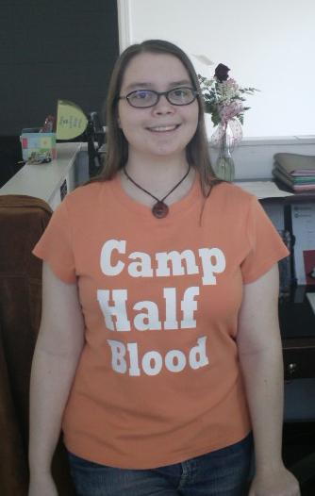

E-mail : ckat13@hughes.net
Website : http://www.freewebs.com/angrysammy/
Location : U.S. – East TN
Accents : American, American Southern, English, French
Bio : Celia’s love of voices and making funny noises began as a child, but it was not until high school that she began to hone it as a skill. She competed in drama tournaments with her drama club, and then later began practicing with online voice work, both for her own projects and for others. Celia has interned at the East Tennessee Radio Group, where she learned more about the mixing and editing process as well as gained more experience with recording.

Feel free to contact Celia regarding voice acting for your projects!

